How to make a Vacuum Chamber
Materials
You will need an adult to help you assemble the vacuum chamber and its connections. You will need to gather materials from:
- Your house (common items such as a jar, balloon, etc.)
- The fish section of a pet store (valves, tees, tubing)
- The hardware store (Swagelok threaded male connector, nut, o-rings, etc.)
- A drugstore or medical supply store (syringe).
Getting the correct set of connecting pieces that all fit together can be a bit tricky, so there may be some trial-and-error involved in getting just the right size of valves, tees, tubing, Swagelok piece, nuts, and o-rings. Ask an adult who is handy at fixing things around the house to get involved! You can also get help at the hardware store as to how to assemble Swagelok pieces.
- It is easiest to first buy the check valves and tees, as well as the tubing that will fit over the ends of the valves and tees – all of these can be bought at a pet store.
- Next, buy the syringe such that the tip fits snuggly inside the tubing.
- Finally, it is best to buy the items form the hardware store, such that the tubing fits snuggly into the Swagelok connector, and that the o-rings and nut fit onto the threaded part of the Swagelok connector.

From around the house:
- 1 glass jar and lid (large canning jar works best, ~1L capacity)
- Large balloon, tied-closed but only slightly inflated
- Large marshmallow
- Stop watch that beeps

From the Fish Section of a Pet Store:
2 check valves; Marina brand (model A1165) work well (there is 1 valve per box) | 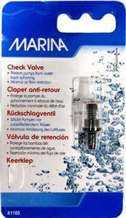
2 Tees, ToM brand Item No. 117 work well (there are 4 Tees per box) | 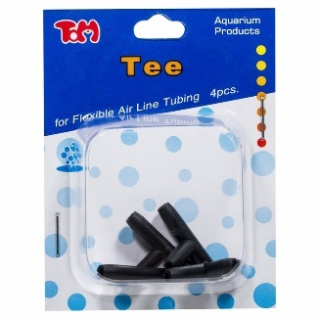
Clear plastic tubing (2.5 feet is more than enough), such that tubing fits snuggly through swage piece, and such that the ends of the Tees and valves fit tightly into the tubing | 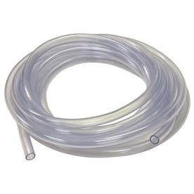

From a hardware store:
Swagelok tube fitting, male connector, threaded portion should be ~ 1” (longer than what is shown in picture). An adult must help in assembling the Swagelok fitting piece and sealing the tubing. | 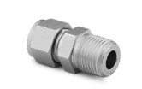
1 hex nut that will screw onto threaded Swage piece shown above | 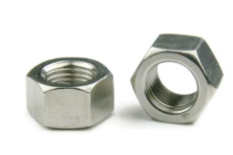
2 o-rings, diameter such that they can be rolled onto threaded part of Swagelok connector, but fit snuggly. | 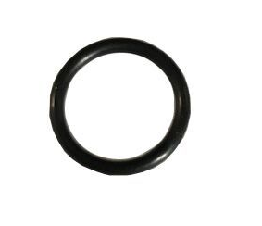
Vice grip locking pliers, or a strong clamp | 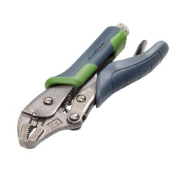

From drug-store (or medical supply store):
- 1 60 mL (2 oz) or larger syringe with tip (Luer Lock type works best); the plastic tip must fit over the syringe tip snuggly

Instructions
Connecting the valves, tees, and tubing:
- Cut the clear plastic tubing into the following lengths (these do not have to be exact)
  - Four ~2” pieces
  - One ~4” piece
  - One ~18” piece

- You will make two Sections (A and B) and connect them with the 18” piece of tubing. The connections for the tubing (shown in red), check-valves (shown in black) and Tees (shown in green) are illustrated as per the diagrams.

  - For Section A: Fit a 2” piece of tubing over each end of a Tee – the fit must be very snug. Fit check valves to the ends of the two pieces of tubing connected to the sides of the Tee. The connections should be snug and the valves must be connected in the directions shown such air can be expelled correctly when you use the vacuum chamber.

2” tubing

Check Valve
Check Valve

2” tubing
2” tubing
Tee

  - For Section B: Fit the middle of the tee into the last piece of 2” tubing. Fit one end of the tee into the 4” piece of tubing.

2” tubing

4” tubing
Tee
  - Connect Section A and B with the 18” piece of tubing as shown. Note that the 18” piece must be fitted to the check valve such that back-flow is prevented when expelling air out of the syringe (see diagram).

Section A
Section B
18” tubing

Preparing the Jar (chamber):
- Seal the end of the 4” piece of tubing (shown in red) to the Swagelok connector (shown in yellow). Ask someone handy to help you do this or look up “swagelok tube fitting” on youtube – there are many great videos that explain how this is done.
- Drill a small hole in the centre of the jar lid (shown in black), wide enough so that the Swagelok connector will fit through it snuggly. Don’t screw the Swagelok connector through the lid yet!
- Roll one of the o-rings (o-ring #1, shown in purple) onto the threaded part of the Swagelok connector (shown in yellow).
- Screw the Swagelok connector (shown in yellow) through the lid of the jar.
- Roll the other o-ring (o-ring #2) onto the threaded part of the Swagelok connector. The lid of the jar will now be sandwiched between the two o-rings.
- Screw the nut onto the threads of the Swagelok connector. Tighten the nut so that the o-rings create a seal around the hole in the jar.
4” piece of tubing from Section B

Swagelok connector
o-ring #1
Jar lid, hole drilled in centre

Hex nut
o-ring #2

Assembling all of the components:
- Fit the 2” piece of tubing of Section A that is not connected to the check valves over the syringe tip. Ensure the fit is snug.
- Close the pliers or place a clamp over the 2” piece of tubing in Section B. This will allow you to release the vacuum after you use the vacuum chamber (otherwise, you can’t open the lid if you have sucked all of the air out!).
- Place an object like the deflated balloon or marshmallow inside the vacuum chamber, close the lid of the jar.

syringe
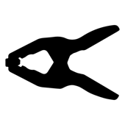
0
Pliers or clamp, squeezing tubing shut

Jar, with object placed inside

The diagram is not to scale, so here are some pictures showing an actual vacuum chamber:

Pictures showing Section A, connected to the syringe, with a close-up of how check valves are connected.
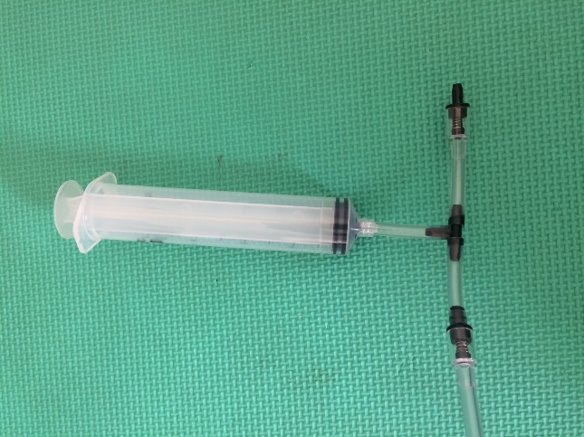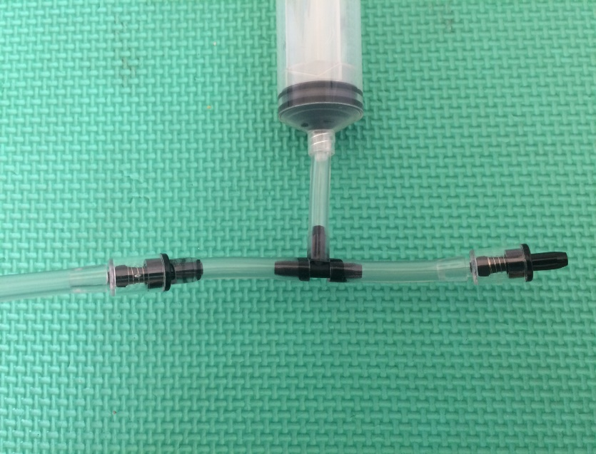
Picture showing Section B, with pliers squeezing 2” piece of tubing.
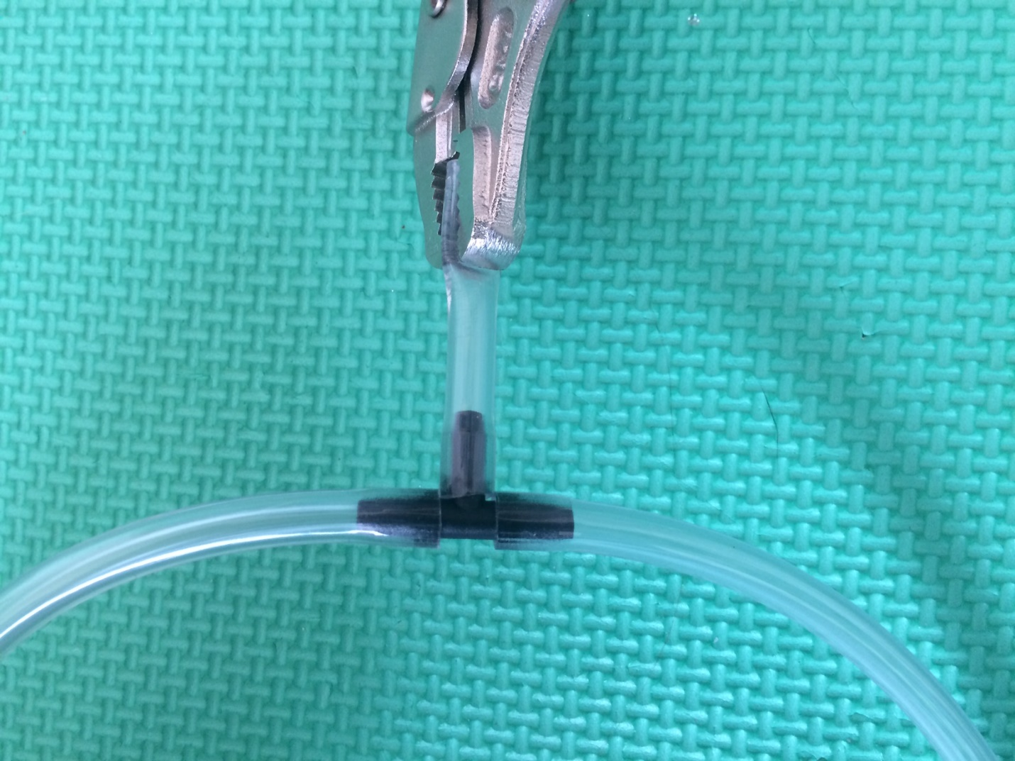
Picture showing top and underside of jar lid
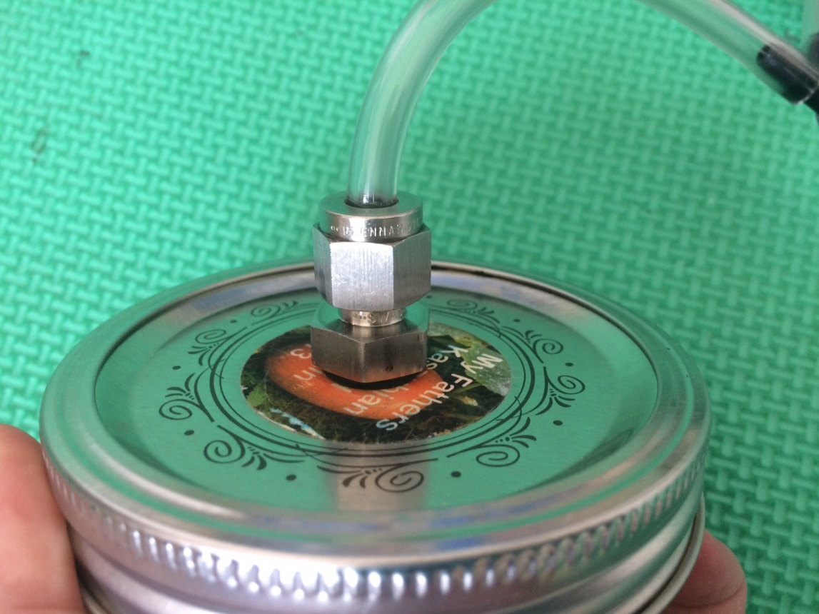
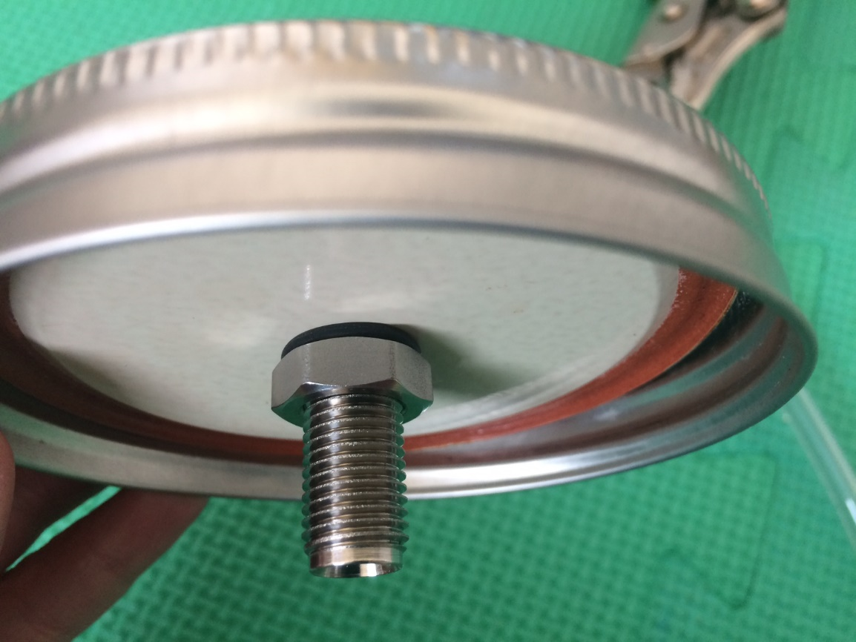

Picture showing entire assembled vacuum chamber:
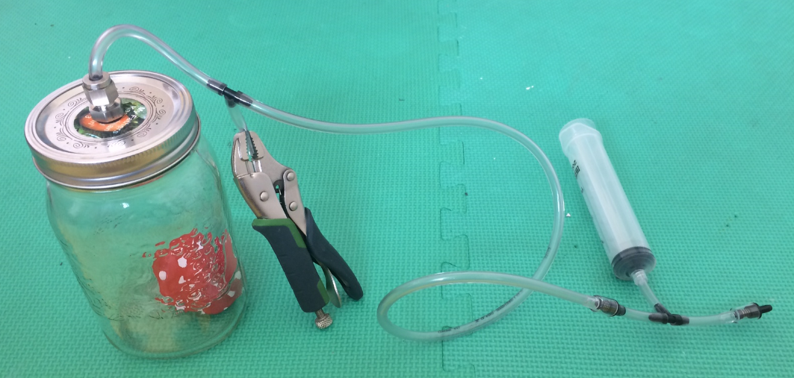

Using the Vacuum Chamber:
- Place a deflated balloon, a marshmallow or a beeping stopwatch inside the vacuum chamber. If using the stopwatch, place on top of a rubber stopper (so that stopwatch does not vibrate directly on the glass).
- Screw the lid onto the jar.
- Close the 2” piece of tubing in Section B with pliers or a clamp to make a seal.
- Begin pumping out the air with the syringe until the balloon inflates or the marshmallow grows, or you can no longer hear the beeping sound from the stopwatch. You can ask an adult to help you as you need to pump the syringe many times (20+) to see an effect.
- To open the vacuum chamber, release the clamp until air has been sucked into the chamber. You should now be able to open the lid.

